ITSM Outage Oct 11 root cause explanation and steps that will prevent it in the future

Incident duration
Incident starts: 0545 UTC +3 on 11 October 2017
Incident ends: 0900 UTC +3 on 12 October 2017

Incident description
When the incident occurred, we experienced unusual CPU load behavior that lead to the inability to serve client requests in time in our AWS availability zone. Part of client requests were never served due to execution timeouts. CPU system time, iowait time and stolen time (the percentage of time a virtual CPU waits for a real CPU) were abnormally high. However, request rate and network load were the same as we usually observing and successfully serving from the date of last application release.

EC2 load chart before rescaling
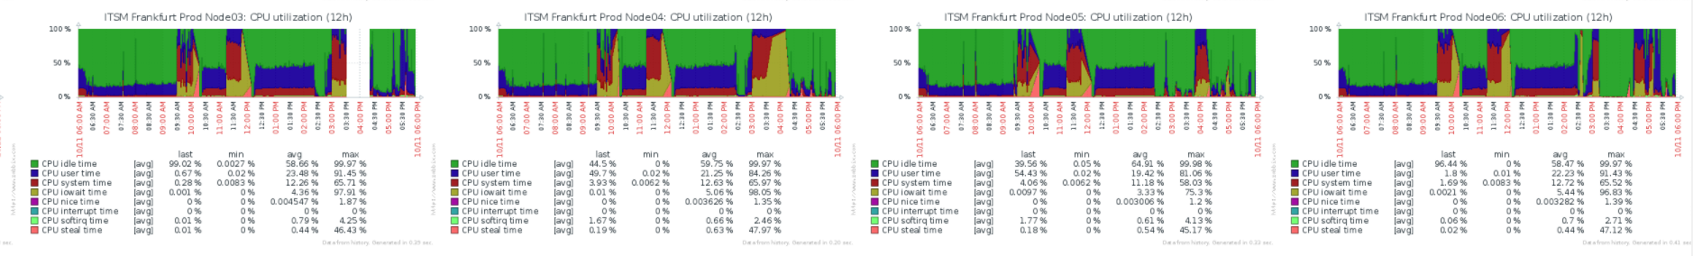
Customer devices response error rate
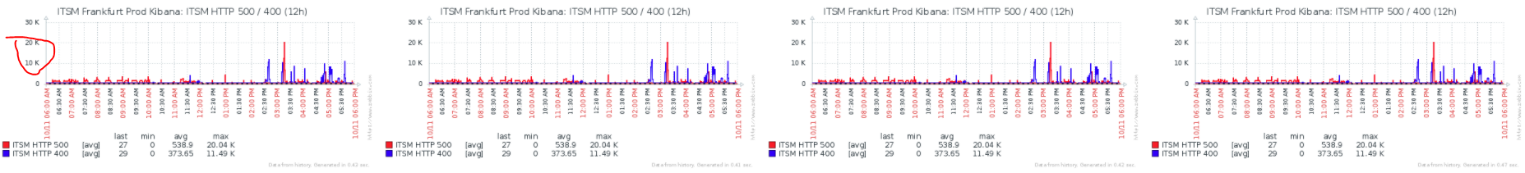

Incident root cause
In ITSM we use AWS EC2 instances on shared hardware to serve our platform. In such case our EC2 instances share common resources with other instances. The rare downside of this is a chance of insufficient CPU time for all instances resides on the same CPU unit. Steal time is the percentage of time a virtual CPU waits for a real CPU while the hypervisor is servicing another virtual processor.

Reaction to incident
As a reaction an incident we changed all affected app nodes instance type to twice the computing power also we increased count of computing nodes. This did not help. AWS hypervisors that runs our instances has no spare CPU time by some reason. After rescaling error rate slightly decreased but was still high. Incident was confirmed by Amazon and still under investigation.
We applied workaround: requests that became slow were excluded from queue. It allowed to serve almost all requests. Situation was back to normal and we switched-off workaround solution.

EC2 load chart after rescaling

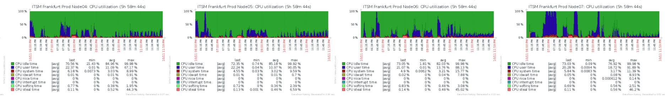

Customer devices response error rate

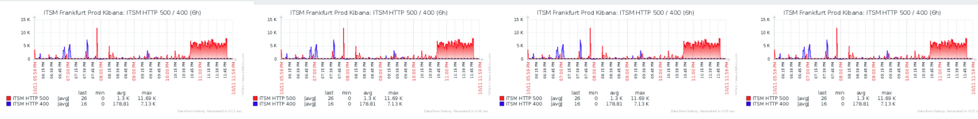

Prevention incident in future
As a permanent fix we will distribute application nodes between different AWS availability zones in same region. If the same incident happen again it will not affect all our instances and we can serve customers requests without issues.

