The priority levels you assign to a ticket are at at your discretion. However, here are some general definitions which may help you to decide ticket priority within your setup:

* Low - Customer is not experiencing loss of functionality or system errors. For example, these may be general use questions, suggestions or future enhancement requests.
* Normal - Customer has loss of non-critical functionality. Customer can function and there are workarounds available. Customer issue may even be covered by existing documentation.
* High - Customer product/service is functioning in severely reduced capacity. Significant impact to the customer's operating and productivity. Potential loss of data or interruption of service.
* Critical - Customer product/service is completely down or not functioning. Customer has experienced loss of production data and no workaround is possible.

The priorities above are determined by a strict 'customer-experience' level. As a company, however, the priority you assign to a particular ticket may also be influenced by other factors, including the importance of the customer or whether the ticket is badly overdue. Under default settings in Service Desk, all new tickets have a priority level of 'Normal'.

There are a variety of ways that you can set ticket priority in Service Desk. You can also use priorities as a management tool by creating filters which apply actions to tickets with a certain priority level.

First, you can set default ticket priority in 'Settings' > 'Tickets':

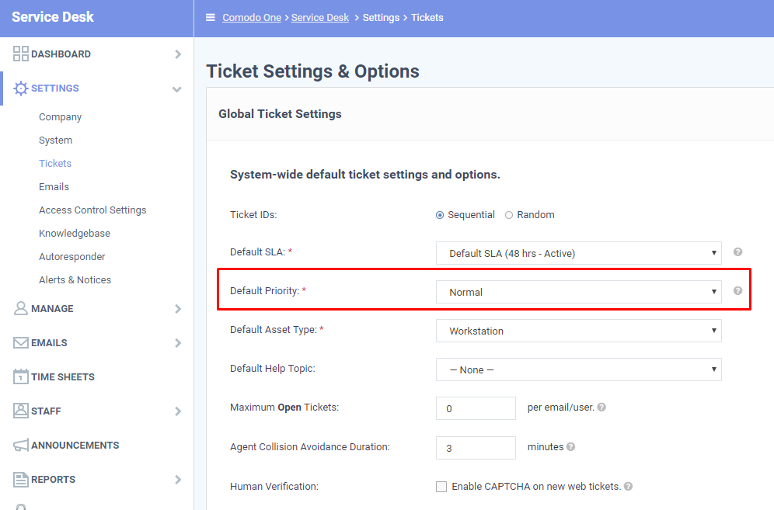

Secondly, you can specify the priority of tickets in help topic stages. You can set the priority of tickets created when customers choose a specific help topic on your support website.

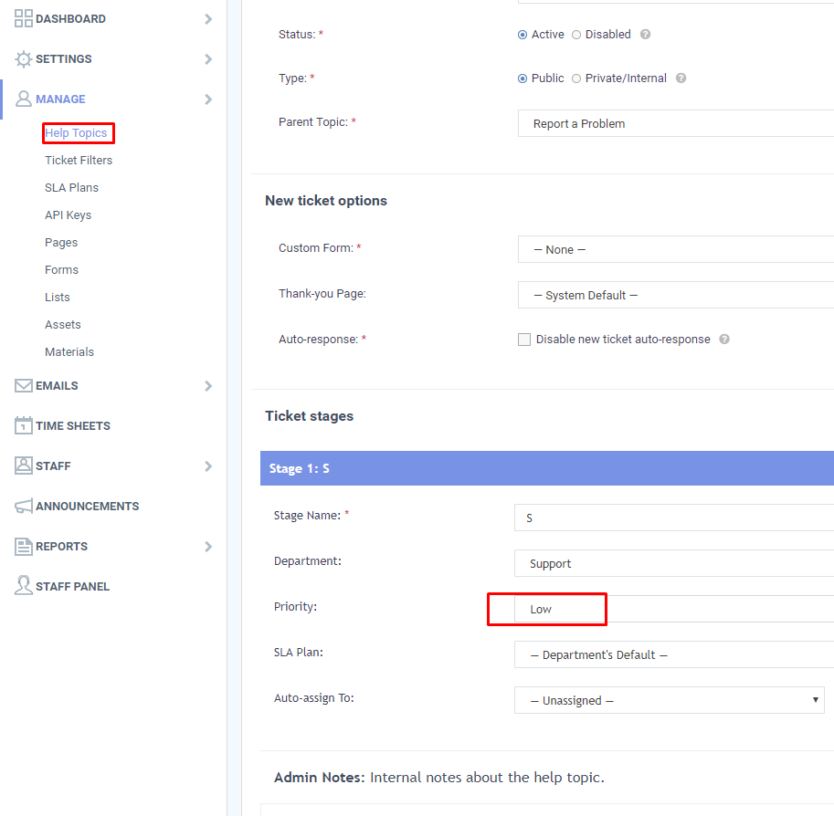

Thirdly, you can create ticket filters which apply actions based on the priority of a ticket:

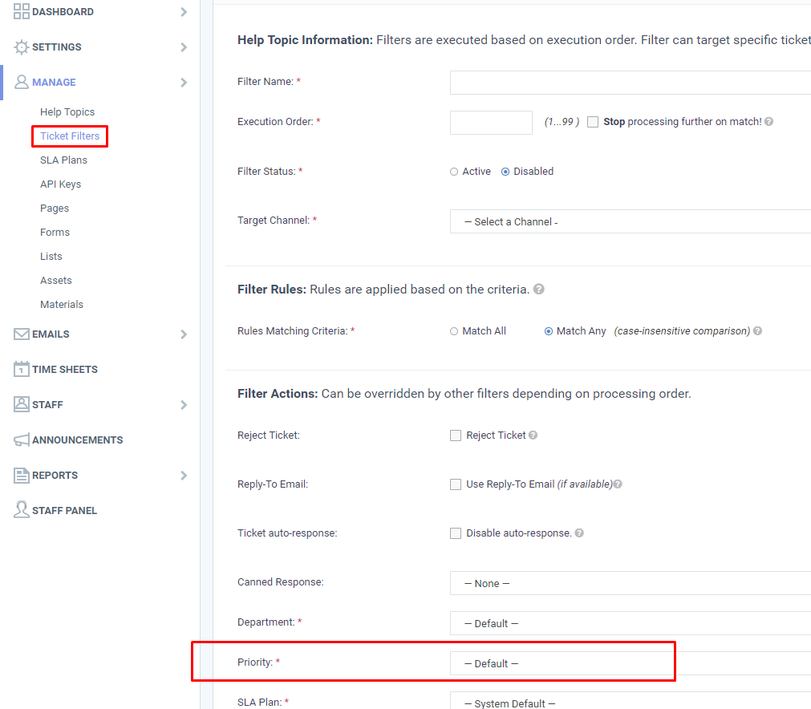

Finally, staff can manually set priority when creating (or working on) a ticket:

